
Air University, Aerospace and Aviation Campus, Kamra
Department of Aviation Management
BS. Aviation Management

Lab Task No. | 03
Title | ICT-Lab 03
Registration ID | 2520269
Semester | BS(Avi)
Submitted By | Roheela
Submitted To | SIR Moeen ui deen  No table of contents entries found.en  Lab Engineer (Aviation Management)  Department of Aviation Management, AACK
Remarks by Teacher:

Contents:
Student overview……………………………………………………………………………1
Branding Statement………………………………………………………………………2
Personal Branding Profiles……………………………………………………………….3
Instgram…………………………………………………………………………………..4
LinkedIn………………………………………………………………………………….5
Github…………………………………………………………………………………….6
Personal Branding Strategies……………………………………………………………..7
Colour Theme…………………………………………………………………………….8
Conclusion………………………………………………………………………………..9

Student Personal Branding Register
Student overview:
Name: Roheela
Degree Program: Aviation Management
University: Air University Kamra
Email: roheehamiya@gmail.com
Phone: 03555276830
Branding Statement:
My goal is to develop a career in aviation industry and aim to play an active role in shaping the industry’s in future by applying modern technology and strategic planning to enhance airlines effectively. I see aviation as global network that unite people and places and I am committed to begin part of that mission.
Personal Branding Profiles:
Instgram:
User Id: roheela
Profile URL: https://www.instagram.com/rohee__la/
Content Strategy: Daily journey of aviation management and updates about aviation
LinkedIn:
User Id: rohee hamiya
Profile URL: https://www.linkedin.com/jobs/
Content Strategy: Aviation management and focused on Airport Management
Github:
User Id:rohee-05
Profile URL: https://github.com/
Profile ReadMe Highlight: Hello, I’m Rohee-- exploring how analytics and technology can streamline flights and elevate the passenger experience
Pin Project: Flight Delay Analytic, Global Flight Network Graph

Personal Branding Strategies:
Rohee uses different platforms to show different strengths:
Instgram: Shares her love for aviation and daily life to connect with friends.
LinkedIn: share studies and professional interests to meet aviation experts, teachers and recruiters
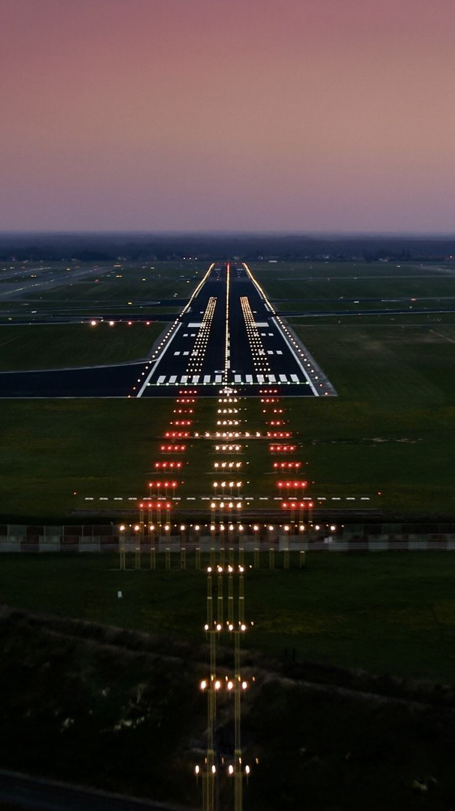
Github: Post aviation projects and work to display tech and management skills
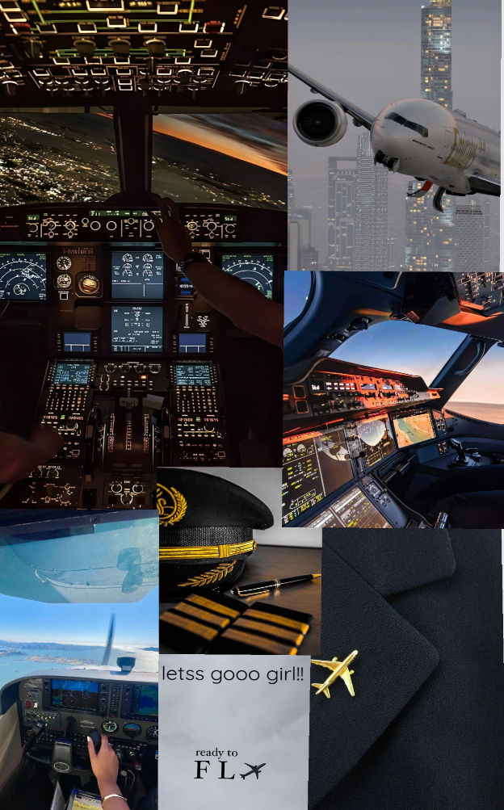

Conclusion:

My brand underscores a tec-driven mindset and positions me as an aviation professional prepared for tomorrow’s challenges
Colour Theme:
Black > #000000

